


Know Your Neighbourhood Autumn Conference

5 November 2024, Bob Jones Community Hub, Wolverhampton

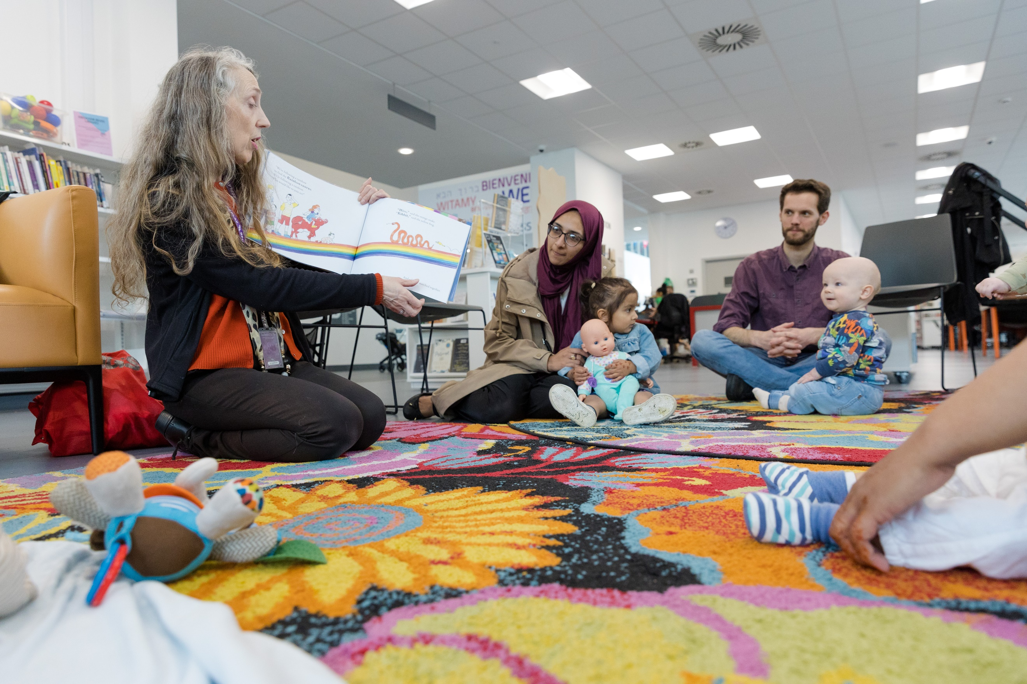

Conference Programme

10.00 – 10.15 | Registration, networking and refreshments
10.15 – 10.35 | In conversation with Marie-Elise Howells, Deputy Director, Volunteering & Tackling Loneliness Team at DCMS and Darren Henley, Chief Executive Office of Arts Council England hosted by Isobel Hunter, Chief Executive of Libraries Connected
10.35 – 11.00 | This session will focus on the two levels of evaluation implemented across the project:  - Overarching Evaluation (Kieran Jones, RSMUK)  A holistic review of the programmes overall reach, drawing connections to assess collective achievements and early learnings.  - ACE Fund Evaluation (Dan Walters, ERS Consulting)  An overview of the evaluation of the ACE funded activities, focussing on key successes of the programme, lessons learned, recommendations and steps moving forward.
 | Case Studies
11.00 – 11.10 | Libraries Connected:  - Kent Libraries representing Thanet region (Sarah Hammond & Lucy Kennedy)
11.10 – 11.20 | Association of Independent Museums:  - Wolverhampton Arts & Culture (Georgina Cheung & Hshaana Caisley)
11.20 – 11.30 | Creative Lives:  - North East Opera will discuss the My Great Folk initiative in Middlesbrough (David Pisaro)
11.30 - 12.30 | Break-out sessions  In-person:  - Funding Opportunities: Insights from Funders facilitated by Andy Wright BEM  - Fostering sustainable partnerships facilitated by Jennifer Robertson (Barnsley) and Jo McQuade (Doncaster)  - Creating Space for Co-production: a reflective exploration of co-production theory and practice facilitated by Jennie Shrewsbury from South Yorkshire Housing Association Limited  Online:  - Designing projects for wellbeing facilitated by Ingrid Scherer  - Creating Space for Co-production: a reflective exploration of co-production theory and practice facilitated by Vicky O’Donoghue from South Yorkshire Housing Association Limited  More details on page 5
12.30 – 13.30 | Lunch break
13.30 - 13.35 | Welcome back from lunch
13.35 – 13.55 | Professor Andrea Wigfield, Director of the Centre for Loneliness Studies & Dr Antonia Ypsilanti, Director of the Campaign to End Loneliness, will share groundbreaking research and insights into the complexities of loneliness.  The presentation will delve into the latest findings on how loneliness impacts individuals and communities, exploring effective strategies for addressing this pressing issue.
13.55 – 14.15 | Amanda Naylor, Chief Executive of Volunteering Matters, will present her research and expert insights on the evolving landscape of volunteering. She will explore the latest trends, challenges and opportunities within the sector, offering a comprehensive overview of how volunteering impacts communities and organisations.
14.15 – 14.35 | Damilola Bamidele, Head of Programmes at UK Community Foundation & Zoe Sweeney, Programme Manager at Heart of England Community Foundation  - An introduction to UK Community Foundations  - Learnings from UK Community Foundation projects
14.35 – 15.10 | Break for refreshments and networking
15.10 – 15.50 | Panel discussion  Empowering progress: Sustaining impact & elevating teams beyond funding  Robin Simpson, Chief Executive of Creative Lives, will host a panel discussion with representatives from each of the ACE Fund partners, including:  - Lisa Ollerhead, Director – Association of Independent Museums  - Leanne Littlewood – Culture House Director, Sunderland Libraries  - Saul Hewish - Rideout (Creative Arts for Rehabilitation)  - Jide Ashimi – Vocational and wellbeing practitioner and Co-chair Raw Material Music & Media
15.50 - 16.00 | Close

Breakout sessions
The following breakout sessions will be taking place between 11:30-12:30. As this is a hybrid event there will be a different offering depending on whether you will be joining in-person or online.

In person

- Funding Opportunities: Insights from Funders facilitated by Andy Wright BEM
In this session, you will hear directly from funders about best practices for securing grants and funding. This session will provide valuable insights into various funding sources, key criteria for successful applications and hands-on experience through interactive activities. Engage with funders in a Q&A session, develop practical funding strategies and gain actionable takeaways to enhance your organisation’s funding efforts.
- Creating Space for Co-production: a reflective exploration of co-production theory and practice facilitated by Jennie Shrewsbury from South Yorkshire Housing Association Limited

In this session, we will explore what co-production means to you and how the principles of co-production can underpin all of the engagement work you do with your communities. We'll consider which elements are most important to the people we work with and how we can successfully create spaces to build trust and develop honest conversations with our communities. This will be an interactive session with opportunities to reflect on your own practice and gain insight into what works well for other people in the room.
- Fostering sustainable partnerships facilitated by Jennifer Robertson (Barnsley) and Jo McQuade (Doncaster)

Find out how Barnsley and Doncaster Museums have been working in partnership with local charity, B:friend, to deliver creative health activities to socially isolated adults.
In this session, we will share how we embed the 5 ways to wellbeing into our activities. And we will give interactive hands-on examples of how we have been making history and art accessible.
Sign up to the in-person break-out sessions here.

Online

- Designing projects for wellbeing facilitated by Ingrid Scherer
This interactive breakout session will explore what matters for people's wellbeing and how libraries and museums can support people and communities to thrive. Delegates will look at the evidence and case studies from practice and focus on the people and groups who may be struggling and the unique role that heritage can play. Delegates will share their experience, practical tips and advice of what works in different contexts and communities across the country.

- Creating Space for Co-production: a reflective exploration of co-production theory and practice facilitated by Vicky O'Donoghue, Good Practice Mentor; Co-production Lead, South Yorkshire Housing Association
In this session, we will explore what co-production means to you and how the principles of co-production can underpin all of the engagement work you do with your communities. We'll consider which elements are most important to the people we work with and how we can successfully create spaces to build trust and develop honest conversations with our communities. This will be an interactive session with opportunities to reflect on your own practice and gain insight into what works well for other people in the room.

Sign up to the online break-out sessions here.

Creative interludes
For in-person attendees, the conference offers a unique opportunity to engage with interactive, hands-on demonstrations led by various organisations. These sessions will showcase how their programmes are making a real, tangible impact within their community. Whether through creative arts, sports, education or digital inclusion, you’ll get a firsthand look at how these initiatives are transforming communities.
Some activities will run throughout the day, while others have limited availability due to capacity. To secure your spot in the sessions with restricted numbers, please use the links below to pre-book. Rest assured, there will be plenty of activities to explore during the breaks, ensuring you’ll have ample opportunity to experience a full range of activities.
Big me and little me using 3D scanner – Wolverhampton Libraries
Participants will work in 2 groups and after a demo from staff they will 3D scan each other then manipulate the image to show a ‘big me and little me’ which can then be printed out on photo paper to keep. This is a good example of relatively simple tech which can be used to enhance other activities.
Session timing: 9:45-10:10am and 1:00-1:30pm
Max per session: 8
Sign-up: KYN Conference: Creative Interludes Sign-up
Location: Outside main room
What impact do we make? – Tameside Arts Ltd
Write a short script from the perspective of a person whose life has improved after your organisation or group’s input / intervention. This will be shared / performed by a participant or drama facilitator.
Learn some simple Makaton signs, along to a song to celebrate the unique contribution and impact the Voluntary Sector has on people’s lives and the community.
Session timing: 9:45-10:10am and 1:00-1:30pm
Max per session: 20
Sign-up: KYN Conference: Creative Interludes Sign-up
Location: Meeting Rooms 1 & 2
KYN doodle canvas – Blackpool libraries
On a large canvas, large enough for numerous people to gather around, participants will be encouraged to think about their own project; their thoughts and feelings around their project and the impact on their communities. Participants will be encouraged to write, doodle, draw and COVER the canvas as a collective.
Session timing: All day
Sign-up: Not required – contribute throughout the day
Location: Main room
Showcase of Penistone Leisure Centre creatives and visitors – Penistone Leisure Centre
A showcase of the diverse talents of both the creatives and visitors at Penistone Leisure Centre (PLC) over the past year, demonstrating a wide range of projects that have been crafted and enjoyed. PLC attracts individuals of all ages and abilities from the town and surrounding areas, with creative workshops thoughtfully designed to engage everyone. Attendees will also have the unique opportunity to select a box—reminiscent of an advent calendar—containing a hands-on activity from one of 12 featured creatives, offering a taster of their chosen craft.
Sign-up: Not required – drop by throughout the day
Location: Main room
Magic Table – Staffordshire libraries
The Magic Table is proving popular with the target groups in Staffordshire Libraries and provides a wonderful sensory experience, which is adaptable to individual needs. It’s also great fun!
Sign-up: Not required – drop by throughout the day
Location: Main room
Mindful Zine Making – Sunderland libraries
This little booklet offers a moment of calm. If we feel overwhelmed on occasion or we are in need of a bit of ‘me’ time, the doodle zine is something you can keep in your pocket or bag, needs no charging and costs almost nothing.
Session timing: 10:00-10:15am and 2:35-3:10pm
Sign-up: Not required – drop by during breaks
Location: Outside main room
Life story scrapbooks taster session – Halton libraries
Some samples for participants to have a look at, some resources to get them thinking about how a scrapbook might be organised, the sorts of memories they might like to include and the forms that these might take, along with some mini scrapbooks for participants to have a go.
Session timing: 12:45-1:15pm
Sign-up: Not required – drop by during lunch break
Location: Outside main room
Polaroid Postcard Workshop – Sunderland libraries
The idea is based on the user group suggestion of using photography to engage the participants. The idea is relatively simple and centres around the ideas of the project; reducing isolation and improving connections.
Session timing: 10:00-10:15am and 2:35-3:10pm
Sign-up: Not required – drop by during breaks
Location: Outside main room

Speaker biographies

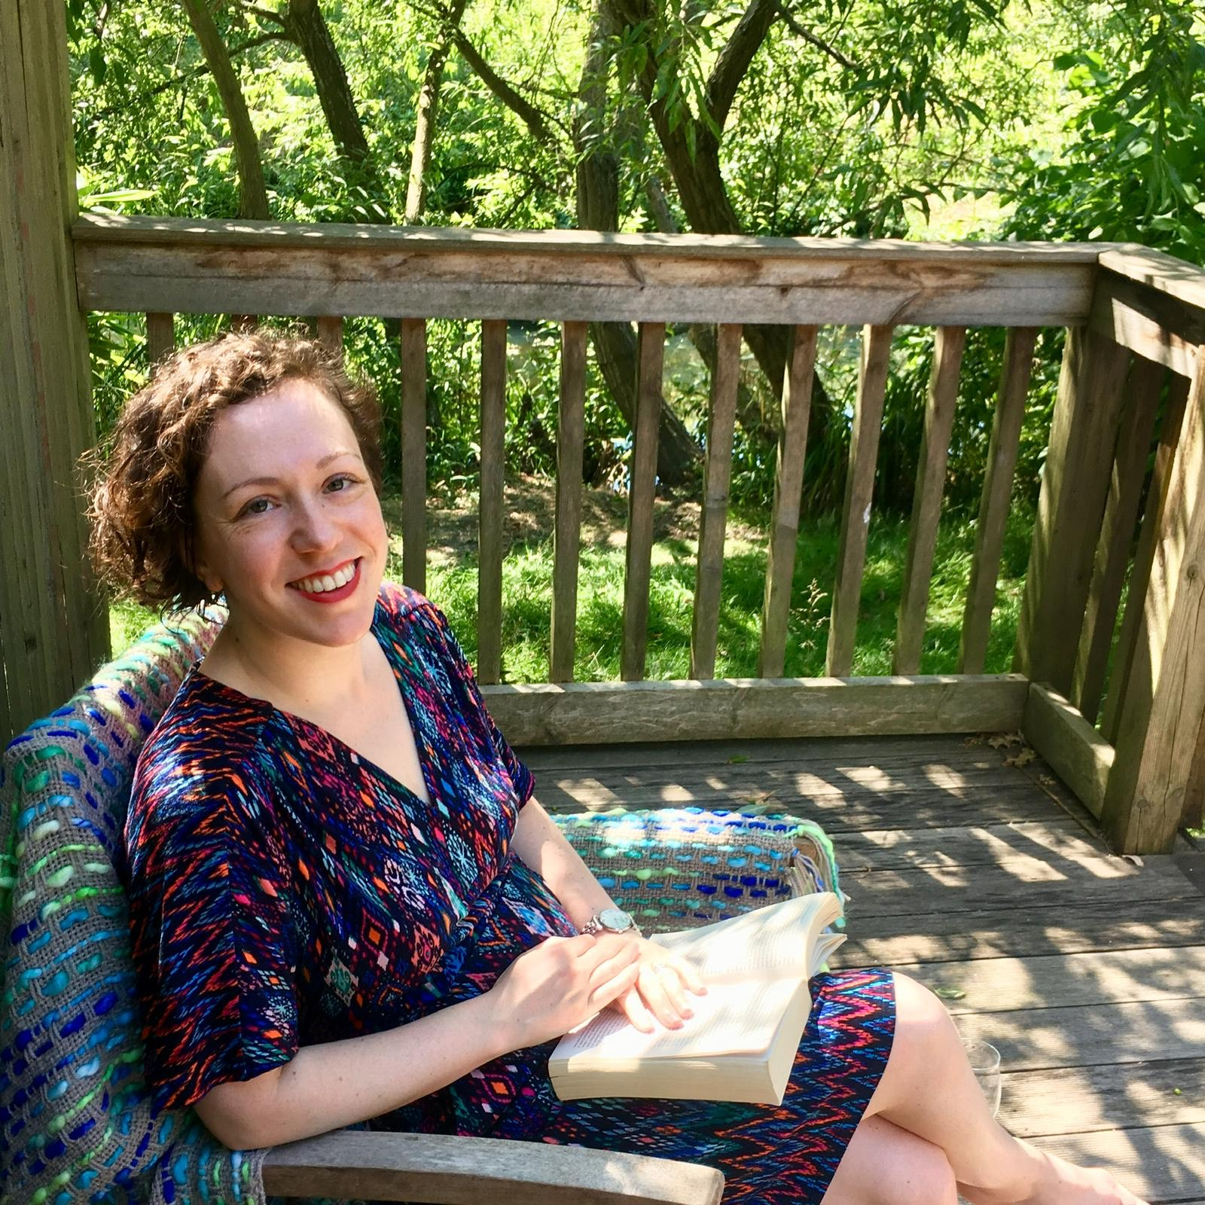
Marie-Elise Howells is head of the volunteering and tackling loneliness team at DCMS and is joining the conference to learn more about how projects come to life for people and communities, and also as senior responsible owner for the Know Your Neighbourhood grant. The team’s work covers volunteering, loneliness, resilience and community projects.
Before joining DCMS Marie-Elise spent a decade at the Department for Education focusing on special educational needs and disabilities and on early years. Outside the civil service she is a volunteer and trustee and has two small children.

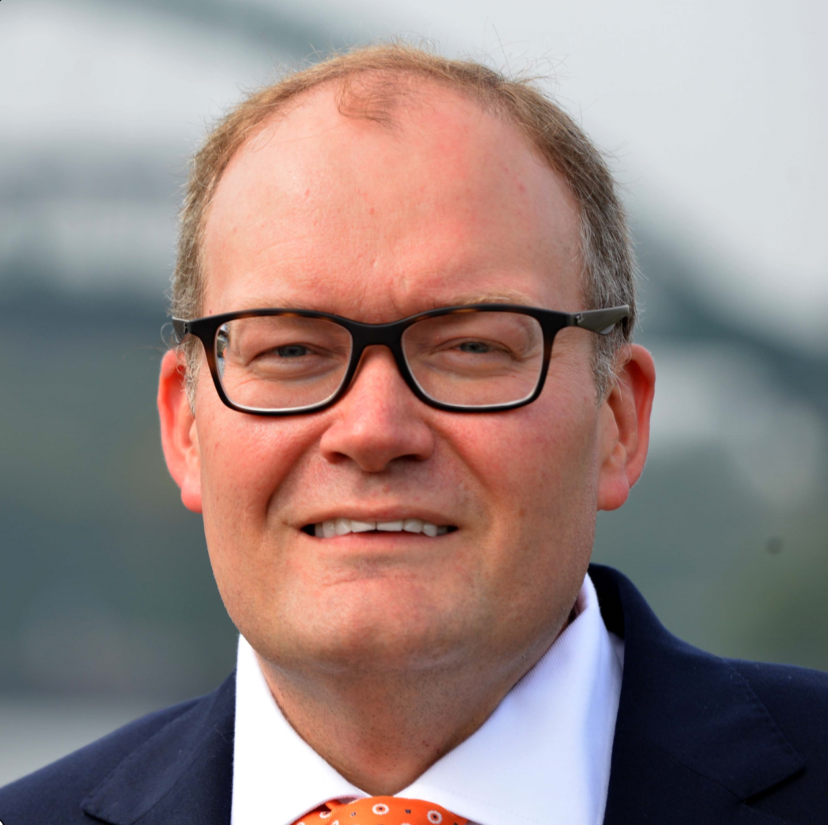
Darren Henley is chief executive of Arts Council England. He chairs the UK National Lottery Forum and the National Lottery Promotions Unit Management Board. Previously managing director of Classic FM, he wrote two independent government reviews into music education and cultural education. He holds a doctorate exploring the role of the outsider as an agent for change, and degrees in history of art, positive psychology, coaching, management and politics. He was appointed OBE for services to music and CBE for services to the arts.
(Image credit Sunderland Echo)

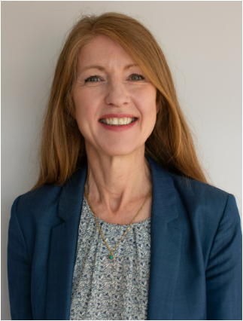
Isobel Hunter is the first Chief Executive of Libraries Connected. She established and grew the organisation from a small team of six to one that now has a dedicated programmes and regional team, with a high profile in national media and with government. She believes that libraries are central to people’s lives and communities across the country and is committed to working with members to help develop and advocate for the public library sector.

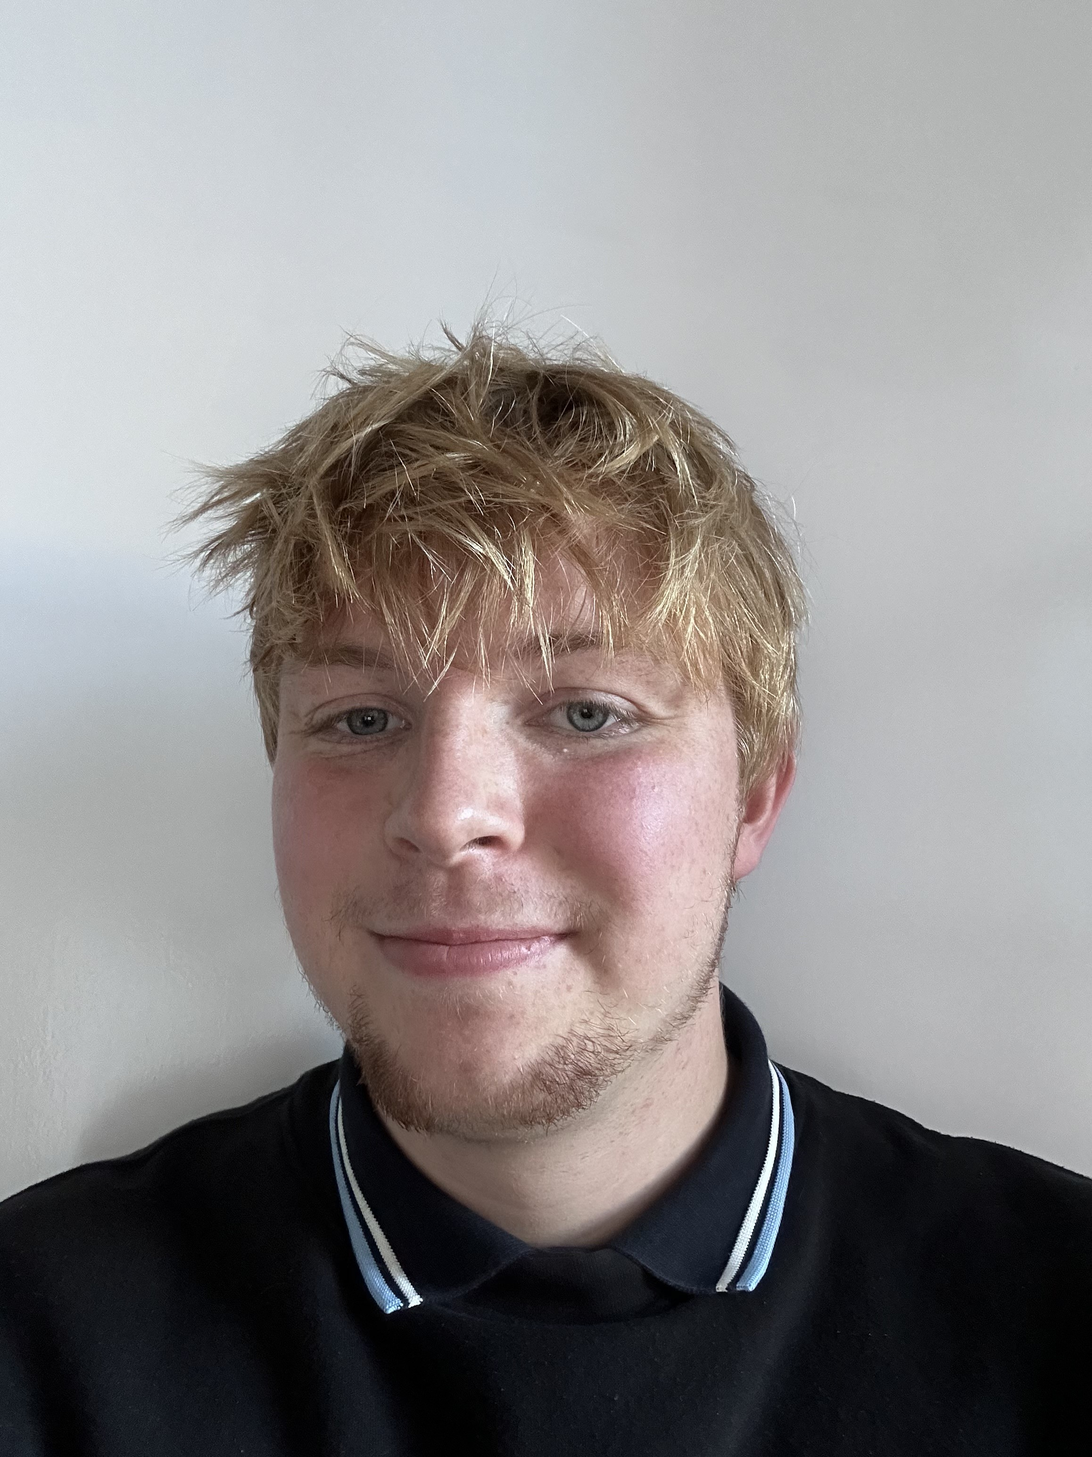
Dan Walters is a Consultant at ERS in Newcastle upon Tyne, having joined the company in 2022. Dan is currently evaluation lead for the Libraries Connected organisations who are delivering activities as part of the Know Your Neighbourhood fund. Dan previous evaluation experience includes working with a wide range of beneficiaries and he specialises in conducting evaluations on projects with a people-centred approach. He has previously delivered on a variety of evaluation and research, notably the British Library Business and IP Centre evaluation 2023, alongside various heritage and cultural programmes and projects.


Kieran Jones is a Director within RSM UK’s Strategy & Economics Team. With over 14 years’ experience, he leads RSM’s research and evaluation work with a focus on the Communities and Youth Sector. He currently leads the independent evaluation of the KYN Fund, working closely with wider colleagues at RSM, NatCen Social Research and the evaluators at ERS and FC Consulting.

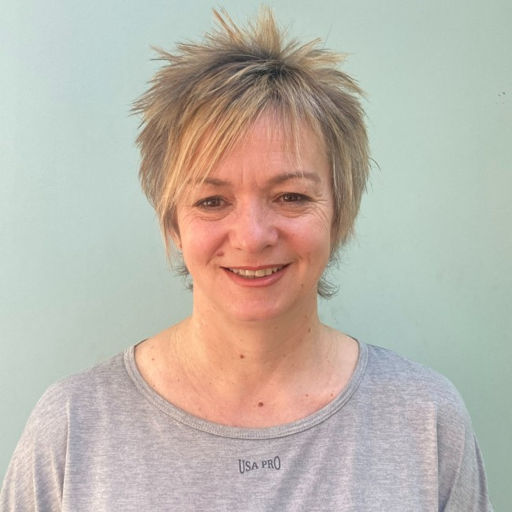
Professor Andrea Wigfield is a leading researcher on loneliness and social isolation, specialising in the wider social determinants and implications through research, programme evaluation, and evidence based policy and practice. The key principles which guide her work are academic rigor and evidence-based research which is policy driven and leads to impact and change. Many aspects of her research focus on co-production involving all key partners in the research process, including ‘experts by experience’.
As Director of the Policy Evaluation Group (2002-11), Deputy and then Co-Director of CIRCLE (2011–2016,) Director of Care-Connect (2014-2017) and currently Director of Centre for Loneliness Studies (2017+) she has spearheaded interdisciplinary research collaboration and established strong networks in both academia and with external stakeholders in the public, private and voluntary sectors. Andrea has been awarded research funding of almost £3 million and has published over 50 books, chapters, articles, and reports, and worked on approximately 90 externally funded research projects.
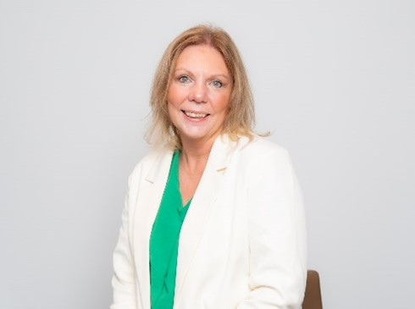
Amanda Naylor OBE, CEO at Volunteering Matters, has 27 years’ experience in the third sector, international development and statutory social care and criminal justice sector. Her work has focused on supporting and safeguarding child victims, disabled children, looked after children, young people subject to safeguarding procedures and young people in youth justice system. At Volunteering Matters she leads an organisation that has over 150 projects across England, Scotland and Wales delivering impactful change in communities through place base volunteering programmes.
Amanda is a Co-Chair at Vision for Volunteering. A collaborative initiative looking at developing a volunteering landscape that meets the needs of volunteers, organisations and communities.

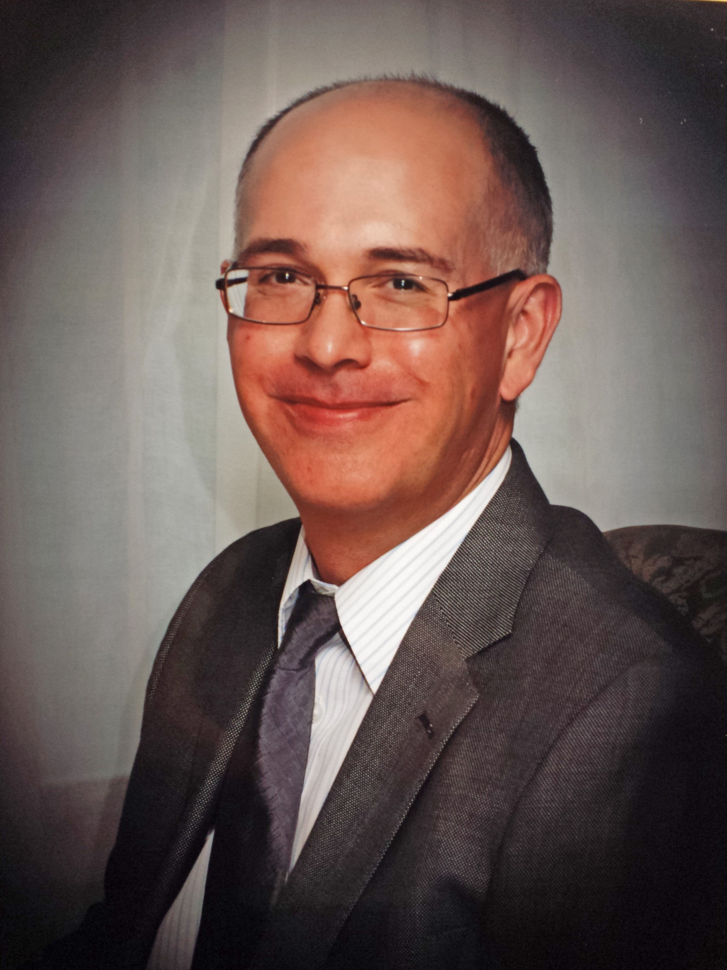
Robin Simpson is Chief Executive of Creative Lives, the UK and Republic of Ireland charity which champions community and volunteer-led creative activity, and works to improve opportunities for everyone to be creative. In particular, Creative Lives celebrates and promotes people expressing themselves creatively with others, recognising the benefits this can bring. Creative Lives works with communities, organisations, policy-makers, funders, communities and creative individuals as a voice for positive change, to improve and expand the landscape in which creative participation can take place. It works to address inequalities in access to creative participation, promotes inclusivity, connects people and communities, and seeks to increase awareness of the links between creativity and wellbeing.

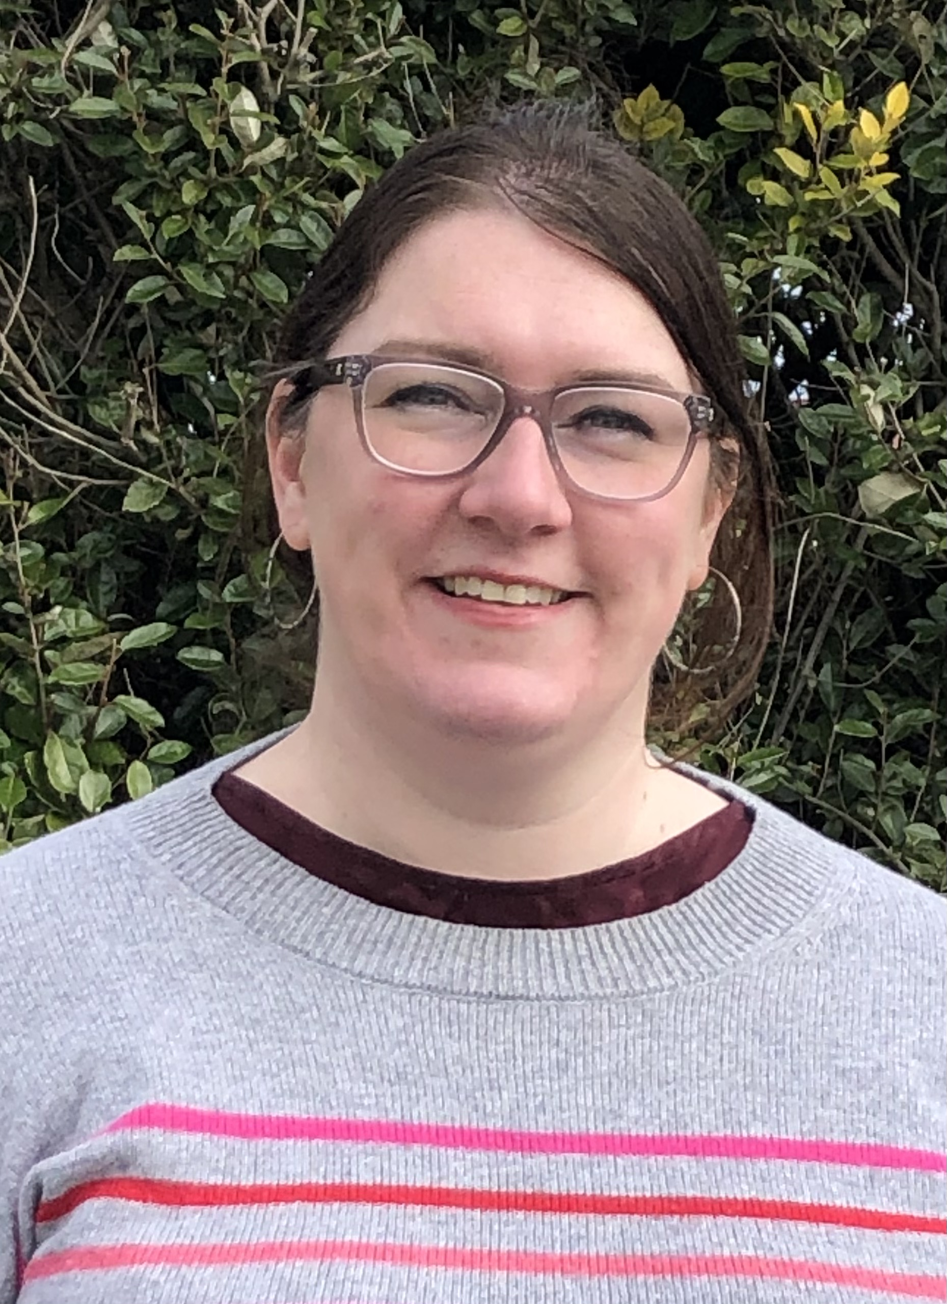
Lisa Ollerhead is Director of AIM, the membership organisation representing the independent museum sector in the UK. AIM is the voice of independent museums and heritage organisations, and offers members practical and pragmatic guidance and advice that helps them run and govern their museums in the best possible way. Lisa joined AIM after five years at the Department of Digital, Culture, Media and Sport, where she worked on museums policy, including the Mendoza Review of museums, the Museum Estate and Development Fund, and the Culture Recovery Fund.

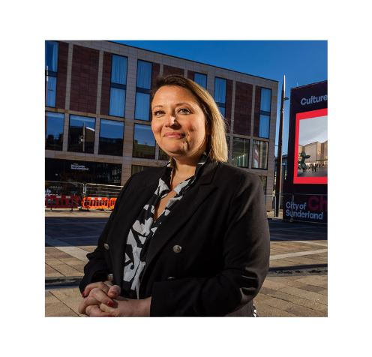
Leanne Littlewood, Director of Culture House Sunderland, has worked in the public sector for approaching two decades. In her current role, she is working with colleagues both in the cultural and city development sphere to shape and deliver 'Culture House Sunderland’. Opening Autumn 2025, Culture House Sunderland: The National Centre for Creative Smart Cities will be a multi-purpose cultural venue, home to the City Library, and packed with dynamic, digitally powered, interactive, educating features and a year-round programme of fun things to do. Leanne joined Sunderland City Council in 2023 from Middlesbrough Council where she held various roles within the Culture Portfolio including ‘Head of Culture’.

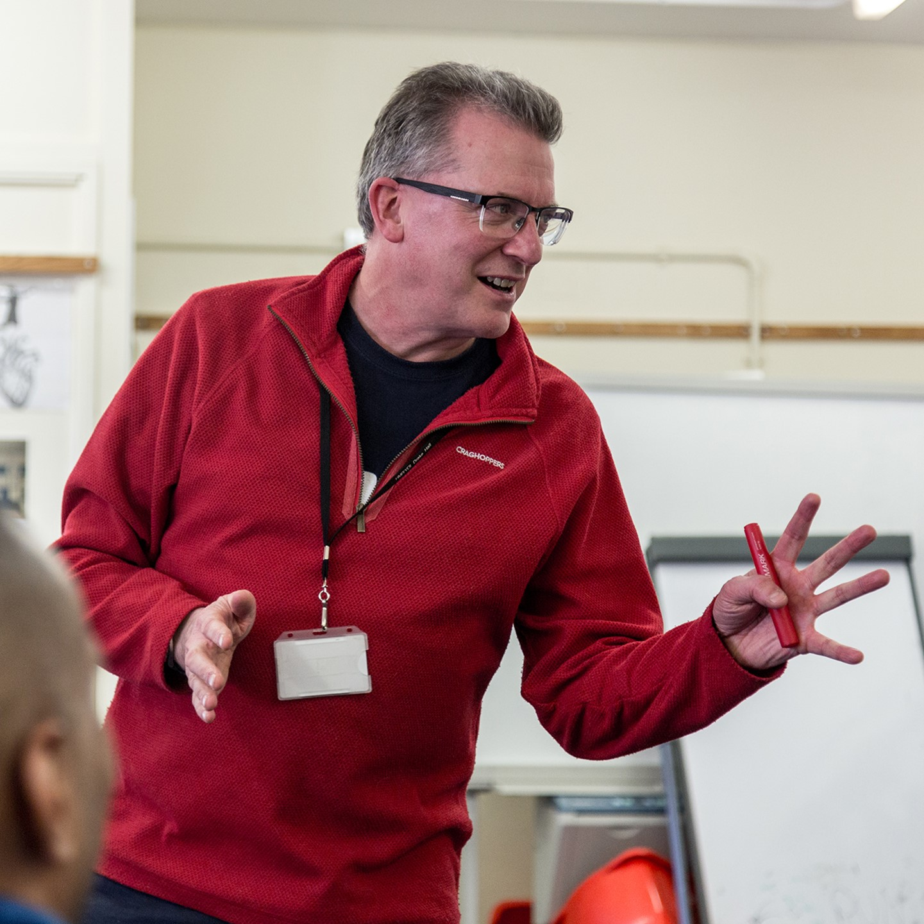
Saul Hewish is Artistic Director for Rideout (Creative Arts for Rehabilitation). He is a specialist in using drama, theatre and related arts with people who experience multiple disadvantage, especially those within the criminal justice system. Prior to co-founding Rideout in 1999 he was a founding member and former director of Geese Theatre Company UK (set 1987). In addition to his work with Rideout, Saul is a Teaching Fellow in Theatre Practice at University of Warwick.

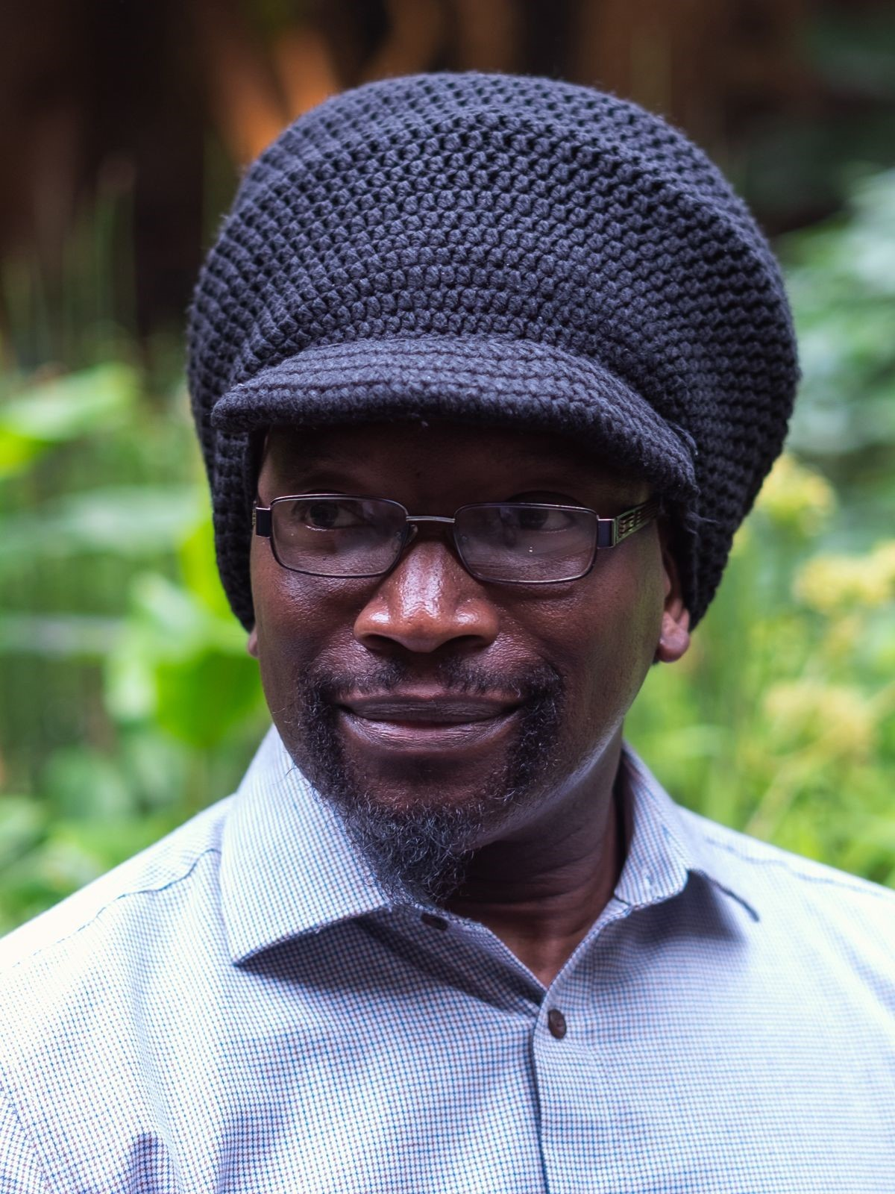
Jide Ashimi is a Vocational and Well-being Practitioner specialising in Mental Health, Creative Arts and Social Inclusion, including Co-design and Co-production. Coach, Lead Facilitator, and Cultural, Equity, Diversity and Inclusion Associate in organisational culture change and leadership development. Co-Chair Raw Material Music & Media.

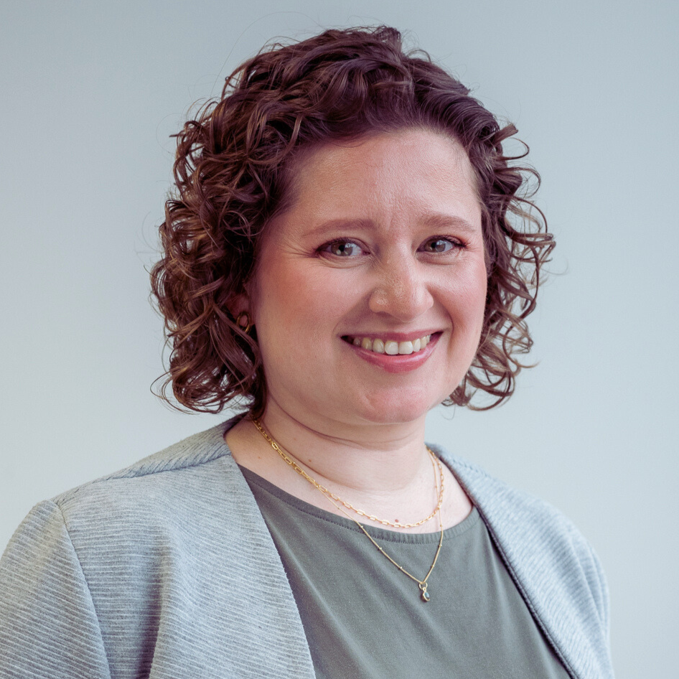
Ingrid Scherer works with charities, social enterprises and those who fund them to understand and grow their impact on wellbeing. She has developed guides and resources for charities, including the Online Guide to Measuring Wellbeing Impact, a Brief Guide to Measuring Loneliness, and a Guide to Effective Case Studies. She has worked for the What Works Centre for Wellbeing and National Academy for Social Prescribing, and is Research Consultant at the VCSE Observatory at Nottingham Trent University.

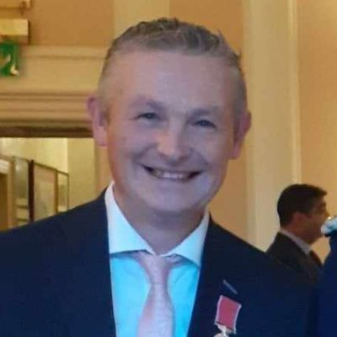
Andy Wright has 35 years’ experience in the public library sector, having worked in Wakefield and Kirklees, as well as representing SCL (now Libraries Connected) on a secondment at the Wellcome Trust in 2016, which led to the development of the “Engaging Libraries” grants scheme, which saw Andy work with the Carnegie UK Trust, distributing around £750,000 of funding from Wellcome and the Wolfson foundation to UK library authorities for innovative public engagement programmes between 2017 and 2021.
He now works part time as a freelancer and was recently successful in securing an Arts Council National lottery project grant to deliver creative music workshops for adults and children in public libraries over the school summer holidays. Widely credited with coining (and attempting to define!) the term “libraryness”, Andy is passionate about promoting public libraries as the perfect locations to deliver all kinds of cultural and health & wellbeing related activities.
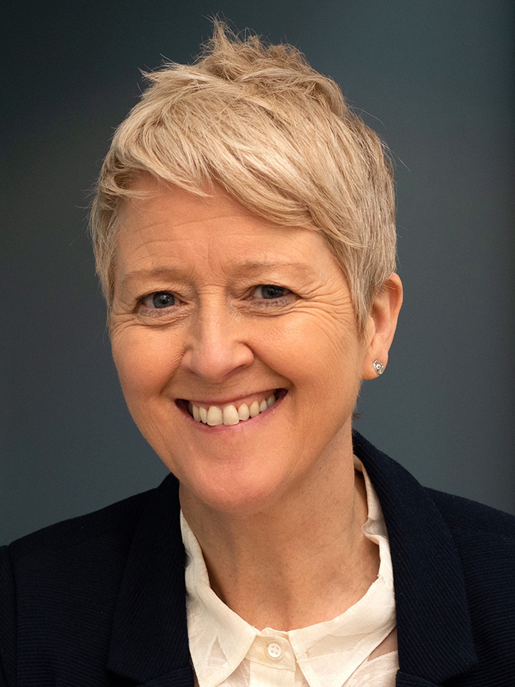
Jennifer Robertson is a freelance project manager for Barnsley Museums & Barnsley Museums Heritage teams, working primarily in engagement and sustainability. Jennifer’s previous background is working in media, photography and teaching, with over 10 years’ experience shooting for National newspapers and magazines.

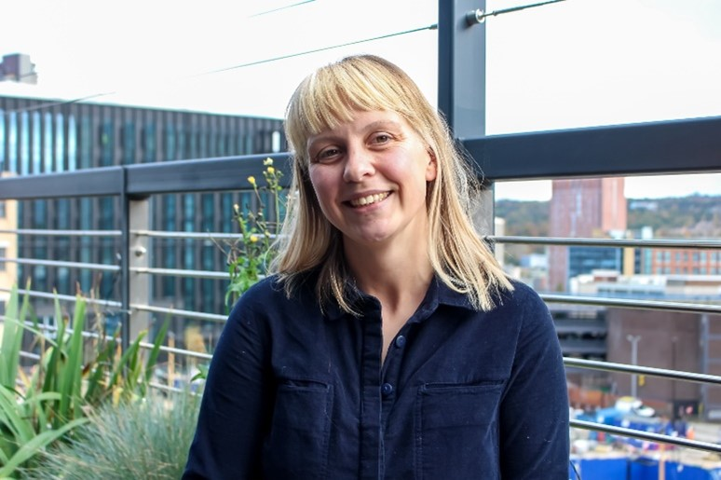
Jennie Shrewsbury, Good Practice Mentor Programme Lead, South Yorkshire Housing Association, is a solution focused practitioner who is passionate about making co-production accessible and achievable for a wide range of organisations, networks and individuals. Based at South Yorkshire Housing Association, Jennie works across the country as part of the Good Practice Mentor Programme, supporting organisations and communities to describe what co-production means to them, and to find easy ways to use co-production in their communities.
Jennie is passionate about working in a strengths-based way and helping people think about their hopes for the future. She has supported teams and organisations with culture and mindset change, and aims to bring organisations together with their communities through person centered connection.
Over the past 6 years Jennie has worked to bring creative and realistic co-production into everyday practice and create a culture where everyone can come together to build on what’s strong.

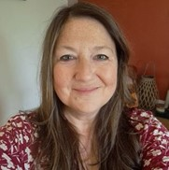
Vicky O'Donoghue, Good Practice Mentor; Co-production Lead, South Yorkshire Housing Association is a training and coaching professional who has almost 25 years’ experience in the field of people development, working within organisational and community settings. As a Good Practice Mentor, she specialises in bringing networks of people together to have meaningful discussion around what good co-production looks like in practice. Vicky is passionate about sharing ways to develop and embed a co-production culture that includes a wide range of diverse voices, fully representing who we are aiming to “work with” and support.
As an advocate for involving those with lived experience at all stages of the co-production journey she believes that good practice enables people from all backgrounds to take part. She runs a series of online sessions through the Good Practice Mentor Programme that opens up an honest and reflective exchange and shares the Stronger Together Toolkit which houses hundreds of tools, resources and stories from 7 years of Ageing Better learning through 12 distinct themes.

Damilola Bamidele, Head of Programmes at UKCF, is a Grant and Programmes professional with over 17 year’s national and international experience devising and leading projects within the education, manufacturing and not for profit sectors. As Head of Programmes at UK Community Foundations she manages and is responsible for the operational delivery of a portfolio of national grant programmes aimed at driving social impact across the UK, working in close collaboration with community foundations. Damilola began her career in education-focused programmes before transitioning to grant-making and programme delivery in various sectors, including private, philanthropic, and public. Having managed both large and small-scale grants programmes, managing relationships with funded organisations and supporting them throughout the life of their grant and evaluation.
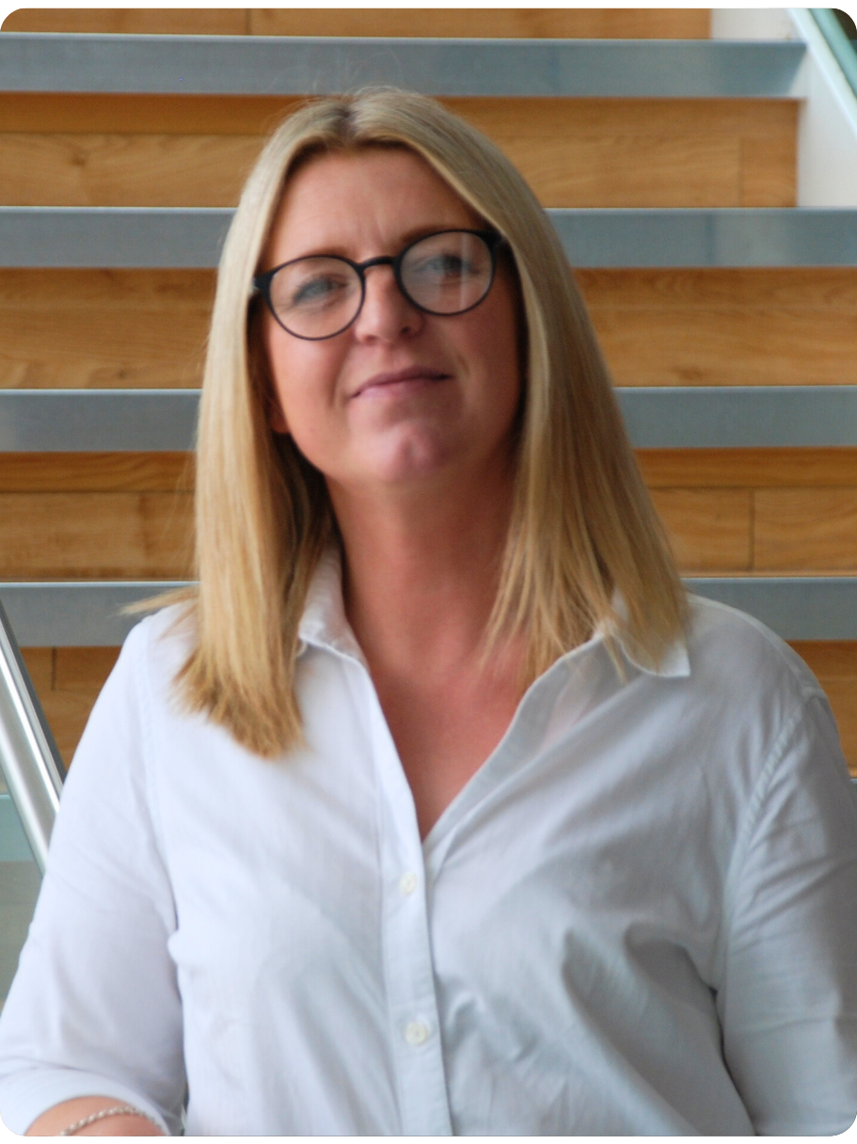
Zoey Sweeney, joined the Heart of England Community Foundation team in November 2023 in the role of Programme Manager, and currently lead the Foundation’s grant making through several of our larger public sector funds. With over 20 years’ experience in business development and project management in the private sector, I made the transition to the charity sector to further my ambition to do more meaningful work, and Heart of England Community Foundation has certainly offered me that opportunity. I pride myself on my ability to develop strong relationships and communicate with organisations across sectors, and have a love of connecting people, to help them grow. With a background in customer focussed roles, my key drivers are people and helping to make a positive change to their lives.

Venue

The conference will take place at the Bob Jones Community Hub, Bromley St, Wolverhampton WV2 3AS. Google Maps location linked here.

Travelling by train

Walking from the train station
Wolverhampton Train Station is 1.3 miles away (approximately a 30 min walk). The route is flat and there are pavements and safe crossings.

Travelling by taxi from the train station
The easiest way to get to the venue from the station is by taxi and there is a taxi rank on the left as you exit the station (marked by the green cross below, with the purple cross showing the station exit). Booking an Uber is also possible, and this area is a good spot to be picked up from. The ride should only be around 5 minutes or so.
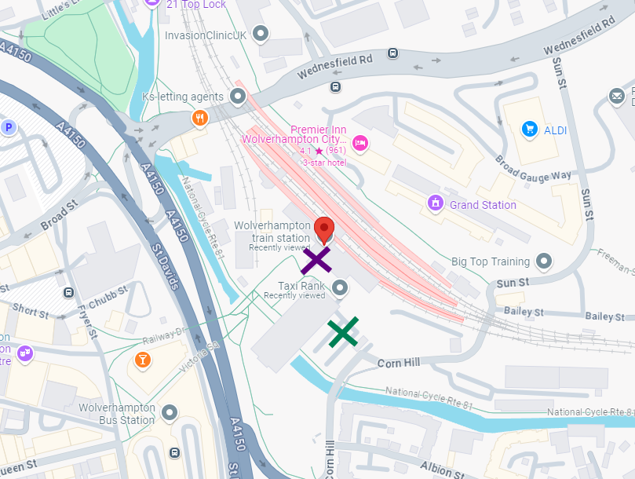

Travelling by bus from the train station

National Express West Midlands buses:
Alternatively, take the number 1 bus from the Police Station or St Georges Parade Old Hall Street (approximately 9-minute walk from the station) towards Dudley and get off on the Dudley Road. These are scheduled every 9 minutes.
There is also the number 25 towards Pendeford which can be boarded at the bus station from Platform A.

Diamond buses:
Alternatively, the number 27 and 27A bus travels from the bus station to just round the corner from the venue. These are scheduled every 30 minutes and tickets can be paid for in advance or on the bus.

Travelling by car

There is limited parking in the car park at the venue, and we are prioritising this for those that may need it most. Unfortunately, these spaces can’t be reserved however, so it will be a case of first come, first served. However, it would be great if attendees could be mindful of this and, where possible, park on the roads nearby.

There is plenty of on street parking around the green space near the venue on Baggott Street, Sedgely Street, Lower Villiers Street and Bromley St, indicated by the purple lines in the image below.

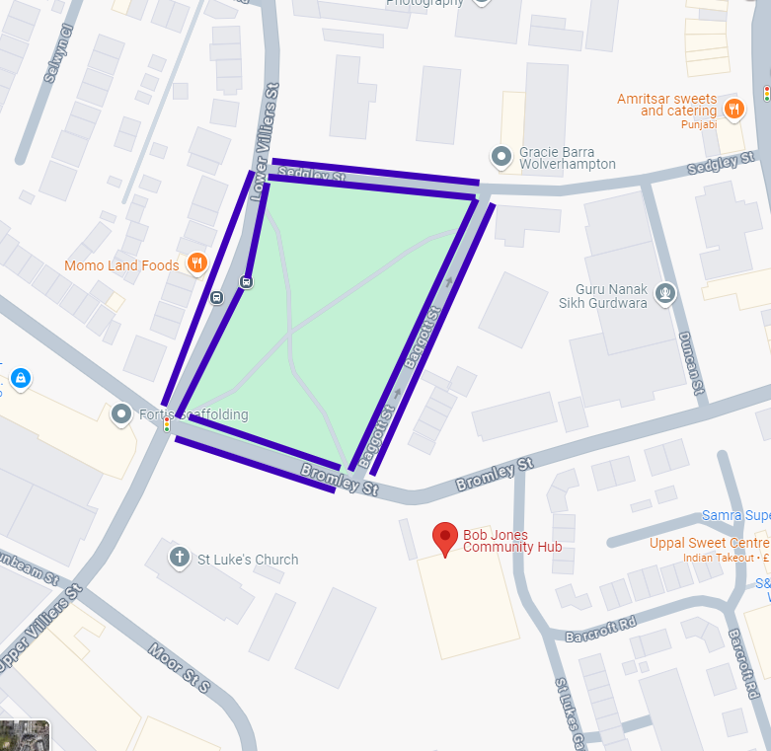

About the Know Your Neighbourhood Fund

The Know Your Neighbourhood (KYN) Fund is an up to £30 million package of funding designed to widen participation in volunteering and tackle loneliness in 27 disadvantaged areas across England. This includes up to £10m of funding delivered by The National Lottery Community Fund.

Of this up to £30 million, £20 million of government investment, and over £1 million of match funding, will support people living in disadvantaged areas to connect with others in their community and engage in volunteering, with the aim of improving wellbeing and pride in place. The National Lottery Community Fund is also investing up to £10 million to support their existing projects working across the same target areas.

Following a competitive process, the Department for Culture, Media and Sport (DCMS) confirmed in January 2023 that £14 million of the total £19 million government funding would be delivered by UK Community Foundations (UKCF) and a consortium of local community foundations across 9 local authority areas. These are: Wolverhampton, South Tyneside, Kingston-upon-Hull, Blackpool, Stoke-on-Trent, Great Yarmouth, Fenland, County Durham and Barrow-in-Furness. This funding is being targeted at people who have not had opportunities to volunteer before, or who are experiencing loneliness. They are being supported to access enriching opportunities that will help to improve their wellbeing, skills, confidence and social connections.

The remaining £5 million of government funding is being invested in supporting people to participate in volunteering and connect with others through expanding the existing offer of arts, culture and heritage activities across the 27 KYN target areas. This funding is being delivered by Arts Council England (ACE) and the National Lottery Heritage Fund (NLHF), in partnership with Historic England.

ACE is delivering funding to arts and culture organisations across the 27 areas through partnership working with three delivery bodies: the Association of Independent Museums, Creative Lives, and Libraries Connected. NLHF is working with Historic England to deliver additional funding through their established High Street Heritage Action Zones programme. The KYN Fund will run until March 2025. A key focus of the programme will be to generate and share learning on how people in disadvantaged areas can be supported to volunteer and improve their social connections, which will help to support sustained action beyond the lifetime of the fund.

For more information visit About the Know Your Neighbourhood Fund.

